Pine Terminal Weevil (Pissodes terminalis) IWP
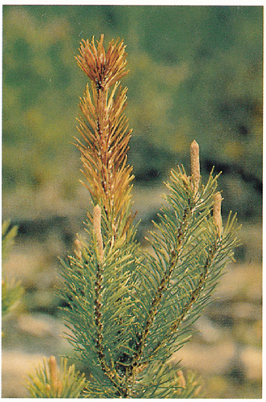
Very Low priority
Description
Species affected are immature lodgepole pine, usually from 1 to 10 m in height. This weevil prefers the most vigorous, open grown trees, and causes terminal dieback of the current year’s growth. Repeated attacks over several years can result in deformed, multi-leader trees.

Extent
This insect is considered a low priority forest health factor in pine plantations.

Data

Tactics
- Incidence levels should continue to be monitored and their priority reassessed at the annual review stage

